**Curriculum Intent, Implementation and Impact Statement**

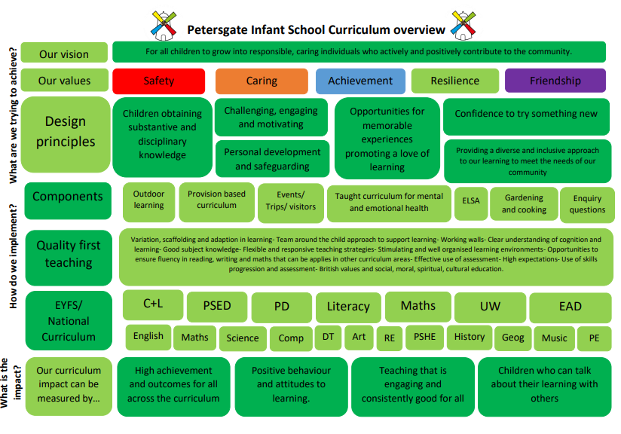

**Our Intention**

At Petersgate Infant School, we are proud to have a curriculum that is designed to inspire curiosity and provide opportunities for children to experience, and develop, skills to prepare them for the next step of their learning journey.

Through our values of **safety, caring, achievement, resilience** and **friendship**, we provide a curriculum which is designed to ensure the best possible outcomes for all children, whilst promoting their well-being in a safe space where they can confidently explore their emotions, individuality and unique identity.

We encourage children to ask questions and help them to develop into independent, flexible thinkers.

Our children are empowered to have courage and develop the confidence to take calculated risks with strength of character and resilience: with the confidence to view every mistake or difficulty as an opportunity to learn.

We implement an enquiry-based curriculum which is rooted in deep respect for others, where they learn how to debate, demonstrate empathy and resolve conflict independently. Whilst planning a learning journey we identify the substantive and disciplinary knowledge that the children will learn. Substantive knowledge is the collection of established facts within a subject. Whilst substantive knowledge is the content that students need to know, Disciplinary knowledge focuses on the skills children will learn.

Petersgate Infant School is committed in educating our pupils about environmental concerns and the importance of living sustainably. We provide an environment in which children are able to explore and respect nature. We are a school which nurtures all those in our Petersgate family and go above and beyond, bringing dogs into school to provide comfort and joy, to build self-esteem and support emotional well-being.

As a school, we fully understand and believe that being out in nature and being outside is fundamental to a child’s emotional and mental health and well-being. The delivery of our outdoor learning sessions has helped in supporting the children’s resilience (one of our key SCARF values), independence, problem solving skills and communication, whilst helping them to feel calmer. Being outside also gives them the opportunity to explore their emotions and how to respond to them. This reflects our SCARF Values and our Zones of Regulation.

As an inclusive school, we are passionate about ensuring children feel they are represented in the curriculum delivered. This may be through the people we learn about, the books we read and the text drivers chosen in English etc. As part of this, all adults and children work together to promote tolerance, responsibility and mutual respect whilst upholding the values of democracy and the rule of law.

We encourage involvement of all stakeholders and members of the community so that we can all be part of shaping young minds and hearts and, together, raising young people who make a positive impact on society.

**How this is implemented**

In order to achieve our aims, Teachers make connections with children’s prior learning, enable cross- curricular links, encourage children to explore enquiry questions, enrich vocabulary and teach using explanation, modelling, scaffolding and practice.

**Outdoor learning**

At Petersgate Infant School we are blessed with the most beautiful school grounds for our children to explore, climb and learn in. As a school, we believe that outdoor learning is an integral part of the curriculum for all children.

We combine and use the pedagogical approaches of:

* learning outdoors (classroom learning transferred to outside i.e. writing outside under a tree)
* learning with the outdoors (natural environment becomes the teaching resource i.e. using our pond for science learning)
* learning through the outdoors (exploring, observing and having first hand experiences with wildlife or understanding seasonal change)

Through our curriculum and additional provision, children explore not just their role in helping the environment but in how they can shape their community and the world they will grow up in.

**Provision based curriculum**

In Early Years the children work towards achieving their Early Learning Goals in 7 key areas through continuous provision and active indoor and outdoor play. Early essential skills in phonics, reading, writing, speaking and listening and maths are practised and developed in readiness for the children moving into Year 1 and the Key Stage 1 National Curriculum.

In KS1 we run an enhanced provision model in which children complete rainbow challenges to support their learning across the National Curriculum subject areas. Progression of the skills and knowledge for each subject area are mapped out so that it is clear what the children will learn in each year group and to ensure all National Curriculum objectives are covered before the children move onto their junior school and into Key Stage 2.

The curriculum is varied where necessary in order to address the needs of all our pupils and the opportunity for revisiting concept’s or skills is fundamental, especially in the core subject areas, to enable children to consolidate and build upon their knowledge, skills and understanding.

Through the use of our learning platform Seesaw, children are able to share their independent learning with their teacher and families. This allows the children to take ownership of their learning, provide feedback to each other and celebrate their successes throughout their learning journeys.

**Events, trips and visitors**

We recognise the importance and benefit of providing wider opportunities and experiences and engaging in local community. Educational visits and trips are organised to broaden aspirations and provide further memorable learning experiences.

We build effective partnerships with parents as we recognise the importance of the collaboration between school and home. Through the learning platform Seesaw, parents are kept well informed of what their child is learning and how this can be supported and consolidated at home. Children are also able to upload their own learning to Seesaw.

As a school, we host regular learn beside your child events in which families are able to experience what a typical school day. We also encourage regular involvement in events such as NSPCC Number day, World Book day, Sports Day etc.

**Taught curriculum for mental health and emotional health**

We are proud to be a part of the myHappymind Family! As a whole school programme grounded in science and dedicated to building positive mental wellbeing, myHappymind helps children understand how their brains work and creates a culture that helps to build children's resilience, confidence, and self-esteem. MyhappyMind also teaches the children how to self-regulate and manage their emotions in stressful times, allowing them to be their very best selves! Learn more here: <https://myhappymind.org/>. Myhappymind is an NHS-backed curriculum in primary schools, secondary schools, and nurseries and is focused on building resilience, self-esteem, and happiness in children. In a world where the mental health of our young is in crisis, we believe that the myHappymind project gives our pupils some of the knowledge and tools to manage these mental health issues themselves as well as understanding when to talk to others and seek help.

**ELSA**

At Petersgate Infant School we are very lucky to have 2 trained ELSAs. An ELSA is a trained member of staff who is trained to support children in the development of their Emotional Literacy. Emotional literacy supports children in the following areas:

* understanding and coping with feelings or ourselves and others
* Developing high self-esteem an positive interactions with others
* Being emotionally literate helps children focus better on their learning.

This can be through a regular session during the school week for 20-30 minutes and sessions can be individual or in small groups and tailored to the child’s individual needs. Sessions are fun and might include role play, puppets, board games, art & craft and stories and include ‘time to talk’.

**Gardening and cooking**

As a school, we promote, teach and support all children with their emotional and mental health and wellbeing through physical education, health education, outdoor learning, providing nutritious meals from our catering service, access to mental health and/or wellbeing support, creating safe and inclusive environments, and implementing programmes that focus on emotional and social development.

At Petersgate we are passionate about exploring the outdoors because we know the impact it has on our children’s mental health and wellbeing. We are lucky to have the grounds we do here which includes the play areas, field, woodlands and our allotment. During each term children join our Well-being and Life skills lead to tend to the allotment and grounds. We also have the opportunity to bring the ‘outdoors indoors’ through The Burrow which provides a space to craft, explore and engage with outdoor learning. The Petersgate Kitchen Garden is a space where children can get hands on with cooking using produce we have grown in the allotment.

**Our Impact**

By the time our pupils leave Petersgate Infant School at the end of Year 2, they are equipped with the skills and knowledge necessary to begin the next stage of their education. This can be seen in the following ways:

* Our children demonstrate confidence, independence and show resilience to challenges, problem solving and change.
* Children have a love and curiosity for learning.
* Our children are able to form meaningful relationships based upon mutual respect and trust, recognising and celebrating difference, not only within the school community, but in the wider world as well.
* Our children have access to a broad and varied curriculum, allowing each of them to flourish as individuals.
* Our children are articulate and confident to talk about a wide range of topics.
* Our children grow up being able to make a positive contribution to the world in which they live.
* Our children actively respond to issues that arise to create a fairer and more sustainable world.
* Our children are well-rounded individuals who understand the importance of Global and British values

Both staff and pupils continuously reflect upon our curriculum in order to develop and improve the quality of learning. These improvements and developments then become part of our School Development and Strategic Plan in order to continue to deliver quality learning outcomes for our pupils.

Phonics is taught using the ‘Little Wandle’ programme to ensure consistency across the year groups with children assessed towards the end of Year 1 using the Phonics Screening Check.

Across the other year groups the children’s progress in all subjects will have been assessed regularly, both formally and informally, using retrieval practice methods such as quizzes or questioning; as well as observations and book looks. Teacher assessment in reading, writing and maths is reported to parents at each milestone (November, February, April and End of Year) and the school compares this with national data.