

 ELSA 

Emotional Literacy Support Assistant

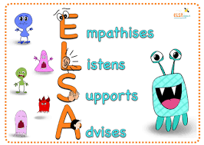

**An ELSA is a member is staff who is trained to support children in the development of their emotional literacy.**

What is Emotional Literacy?

* understanding and coping with feelings or ourselves and others
* Developing high self-esteem an positive interactions with others
* Being emotionally literate helps children focus better on their learning.

Some of the areas the ELSA may work on:

* Recognising emotions
* Self-esteem
* Social skills
* Friendship skills
* Anger management
* Loss and bereavement

How does the ELSA work?

* A regular session during the school week for 20-30 minutes
* Sessions can be individual or in small groups and tailored to the child’s individual needs
* Sessions are fun and might include role play, puppets, board games, art & craft and stories
* They include ‘time to talk’
* A child’s progress will be reviewed on a half-termly basis

As a parent/carer, how can you help?

* By informing the class teacher if there are any issues that may be affecting your child.
* Please feel welcome to contact your child’s teacher or ELSA if you have any questions.

**We have 2 ELSA’s at our school.**

They are:

Mrs Robb Mrs Wright

 

Mrs Robb is sometimes accompanied by Cooper!

